Grossmont College Name: ______________________
MA180 Practice Exam 1 Class section no. : _____________
This exam is worth 100 points. You have 90 minutes to answer. You cannot use any book (textbook), any notes, computer, iPad etc., or cellphones; and cannot communicate with anyone other than the instructor. You may use a calculator (TI84 or lower). You must show clear work to get full credit.
1. (5 pts) Use the formula taught in this class to compute the sum
$1^{3}+2^{3}+3^{3}+⋯+{50}^{3}$

2. (5 pts) Use the integration formula in lecture notes to evaluate the following integral
$\int_{0}^{1}{\frac{1}{1+x^{2}}}dx$

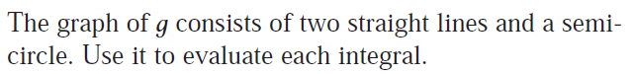
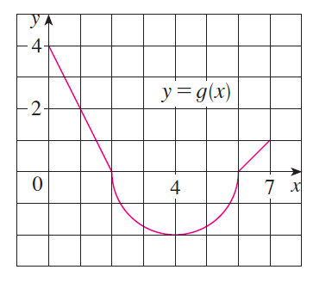
3. (5 pts)
(Hint: the integral will be negative if the curve is below the x-axis)
$\int_{1}^{4}{g\left(x\right)dx}$

4. (5 pts) Express the following limit as a definite integral on the interval [2, 7]
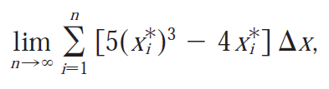

5. (5 pts) Use the appropriate integration formula to evaluate
$\int_{0}^{π/3}{\sec{x}\tan{x} dx}$

6. (5 pts) Set up an integral for the area between the two curves
$y=x^{2}-2x, y=2-(\frac{x^{2}}{2})$
You need to find the upper and lower limit of integration, but do not evaluate the integral.
Use fractions, not decimals.
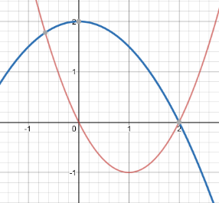

7. (5 pts) Set up the integral to use shell method to find the volume of the solid obtained by
rotating the region bounded by the below line and curve,
(do not evaluate the integral.)

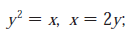
8. (5 pts) Set up the integral to use disc method to find the volume of the solid obtained by rotating the region bounded by the following line and curve, about the y-axis.

(do not evaluate the integral.)

9. (5 pts) How much work (in joules) is done when a hoist lifts a 180-kg rock to a height of 4m?

10. (5 pts) A spring has a natural length of 20cm. If a 25-N force is required to keep it stretched to a length of 30 cm, how much work (in J) is required to stretch it from 20 cm to 25 cm?

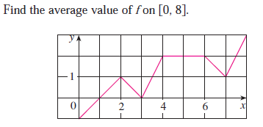
11. (5 pts)

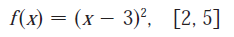
12. (5 pts) Find the average value of the following function on the given interval.

13. a) (3 pts) Sketch the graphs of y = cos x and y = 1 – cos x for 0 ≤ x ≤ 2π. Shade the regions
bounded by the two curves.

b) (3 pts) Find the intersections (i.e. the x-coordinates) of the two curves.

c) (4 pts) Use integration to find the area between the two curves from 0 to 2π. (Hint: split the
integral into 3 parts).

14. (10 pts) Washer method for solid of revolution.
A solid is obtained by rotating the region bounded by the curves (2 – x²) and (x + 1) about the x-axis.
a). Use the guidelines below to draw a washer formed by cutting a thin slice (perpendicular to the x-axis) from the solid. Indicate the thickness, the outer and inner radii.
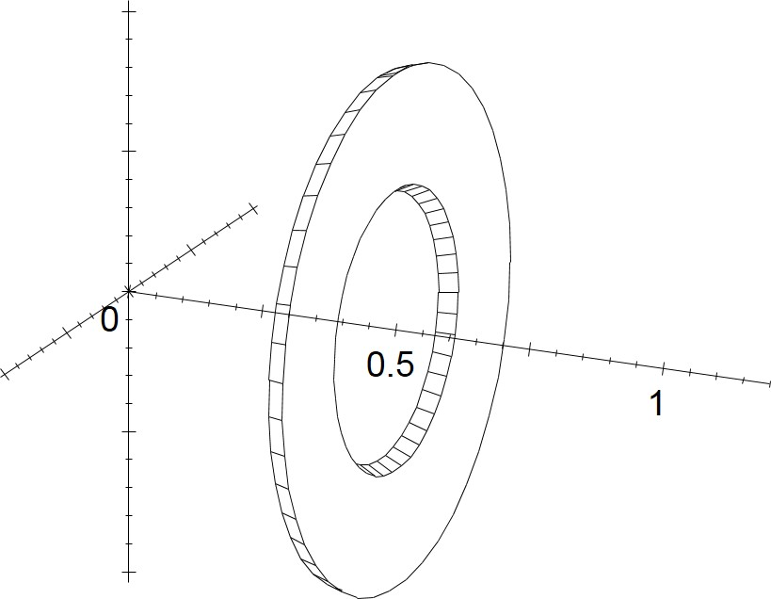
If the x-coordinate of the disc is xi, then
the outer radius of the disc will be
______________ , and the radius of the
hole will be ___________________.
If the thickness of the washer is Δx,
then the volume of this washer will be
__________________________ .

b) Use integration to find the volume of this solid from x = -1 to x = 0.

15. (10 pts) Find the volume of the solid generated by rotating the region bounded by the
“curves”
$y=\sqrt{x}, y=\frac{x}{2},$ about the line x = 5
a) Sketch the region bounded by the “curves”, and show the coordinates of the intersections.

b) Set up a formula for the volume of one generic shell with x = x_{i} and thickness Δx.

c) Set up an integral for the volume of the solid of revolution and then evaluate the integral.

16. (10 pts) A circular swimming pool has a diameter of 24 ft, the depth is constantly 6 ft and water is filled to 1 ft below the sides (i.e. the water is 5 ft deep).
a). If water weighs 62.5 lb/ft³, what is the weight of one thin horizontal “slice” of water from the pool with thickness Δx?

b). If that slice from part (a) is x feet below the edge of the pool, how much work needs to be done to pump that amount of water over the side?

c) Use integration to find the total amount of work (in Joules) needs to pump all water out over the edge of the pool.

